Week 4

Topics:

1. Management tool – **Storage Explorer app** setup
2. Two ways to access containers/folder/directory

Find the storage explorer and download it.

storage account >> any account(like datalake or normal blob) >> tools+SDKs >> Storage Explorer

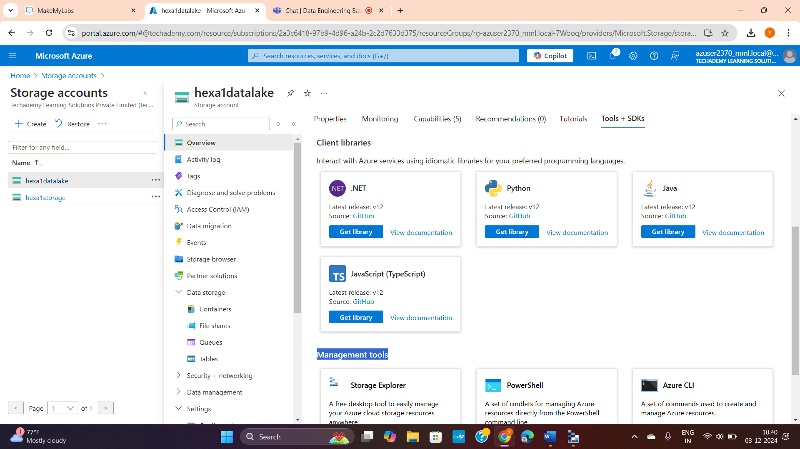

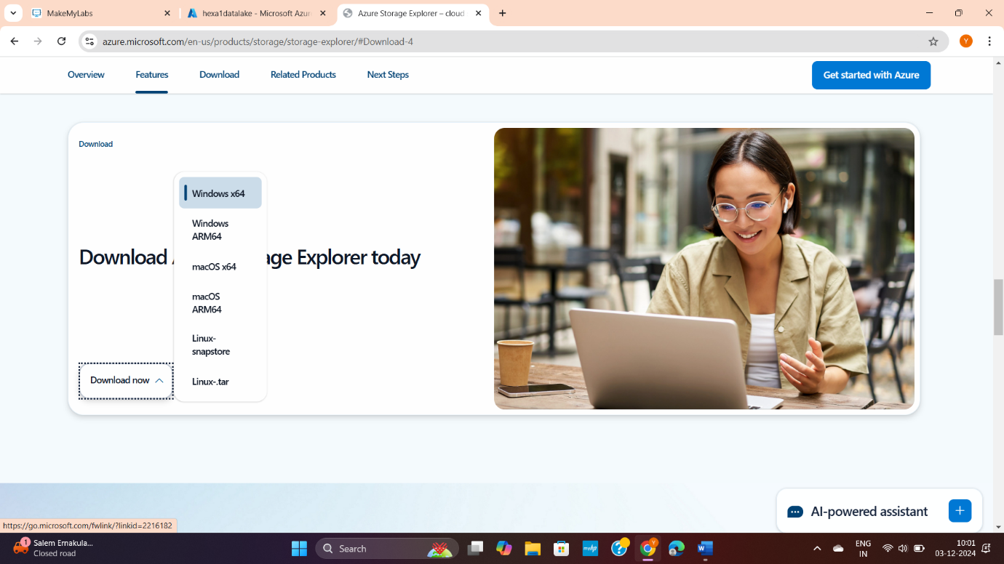

**Two ways:**

1. **Sign-in directly** if it is your account.

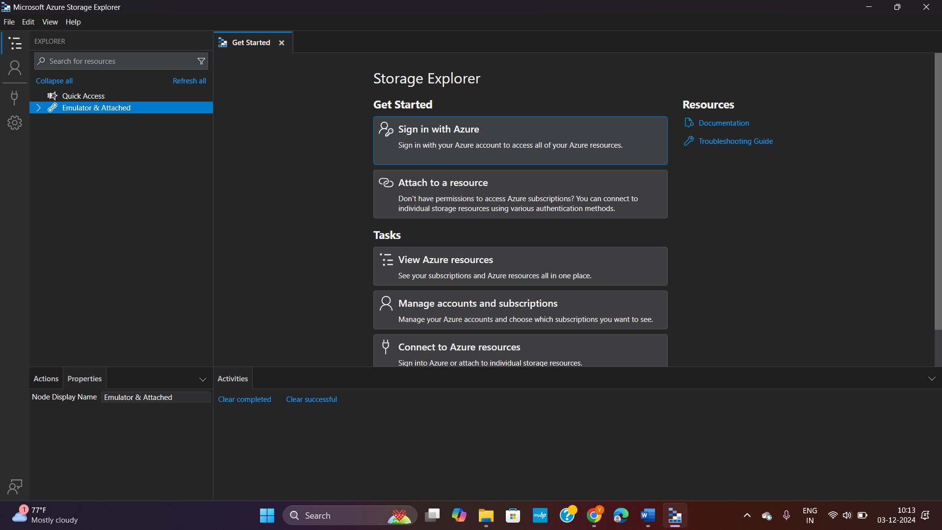

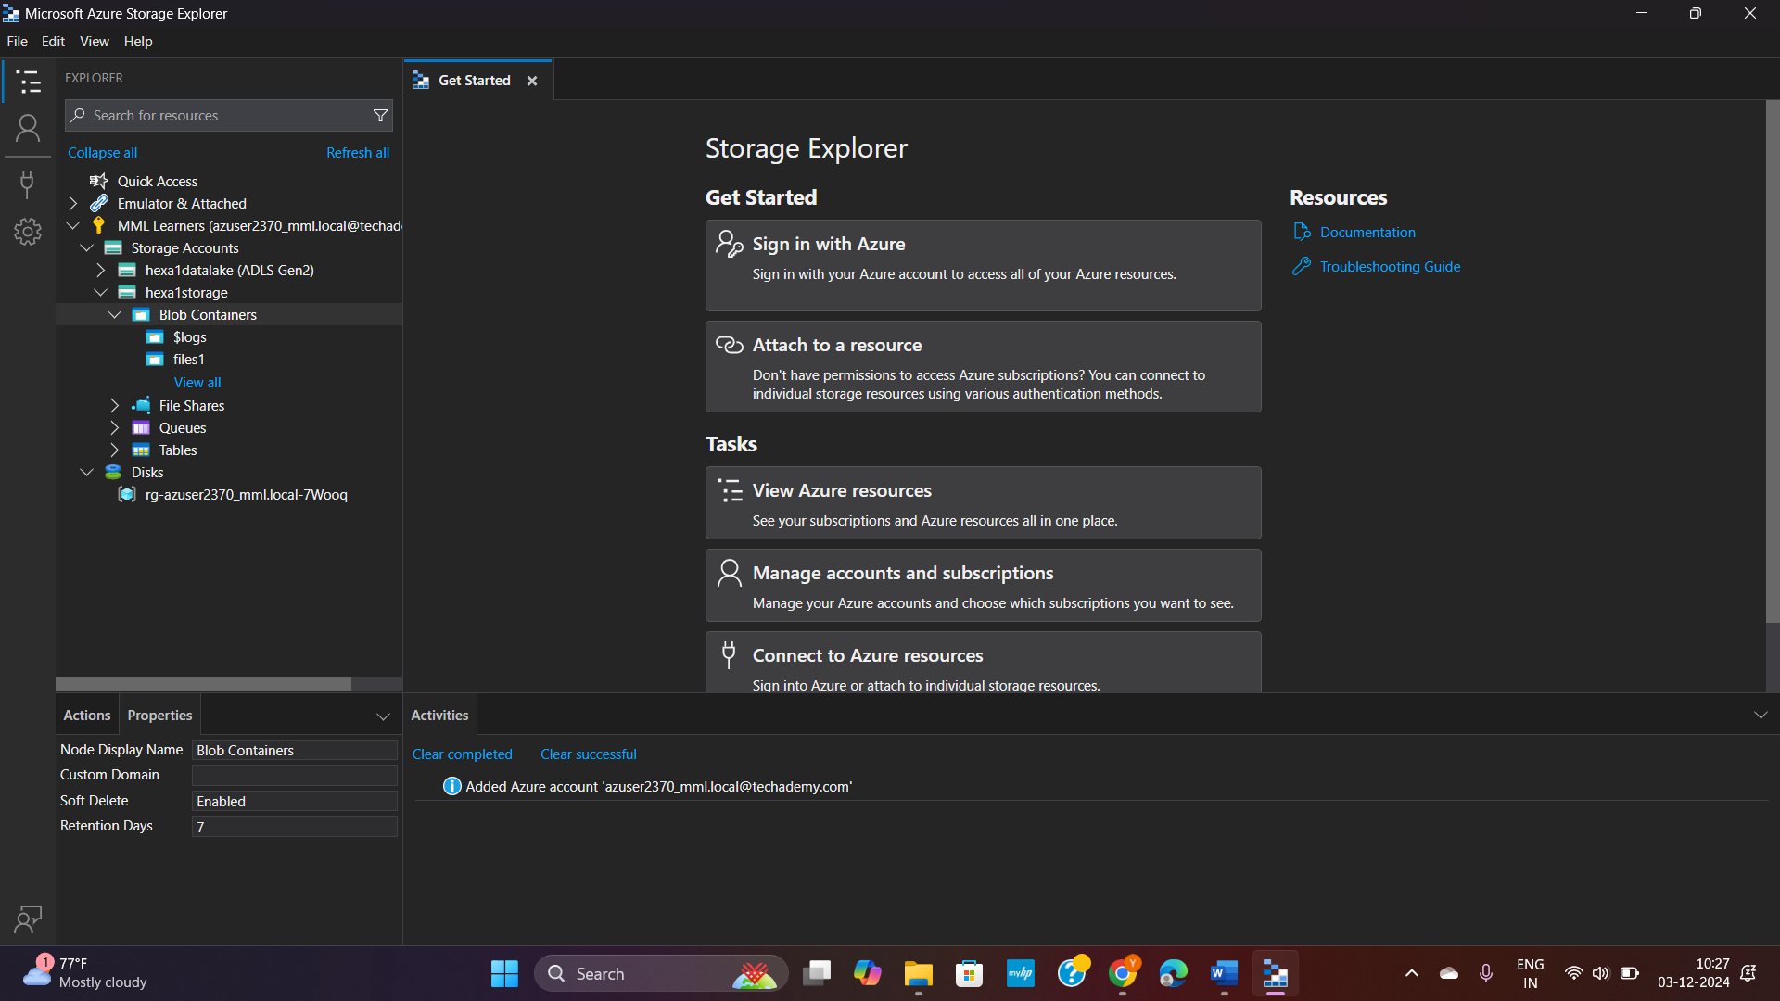

1. Or you can generate a **sharable SAS link** for a particular container (folder) and paste that link in this app to get that container particularly.

Azure >> particular container >> shared access tokens >> generate link

NOTE: set expiry date and **set permissions (read, write, modify etc)**

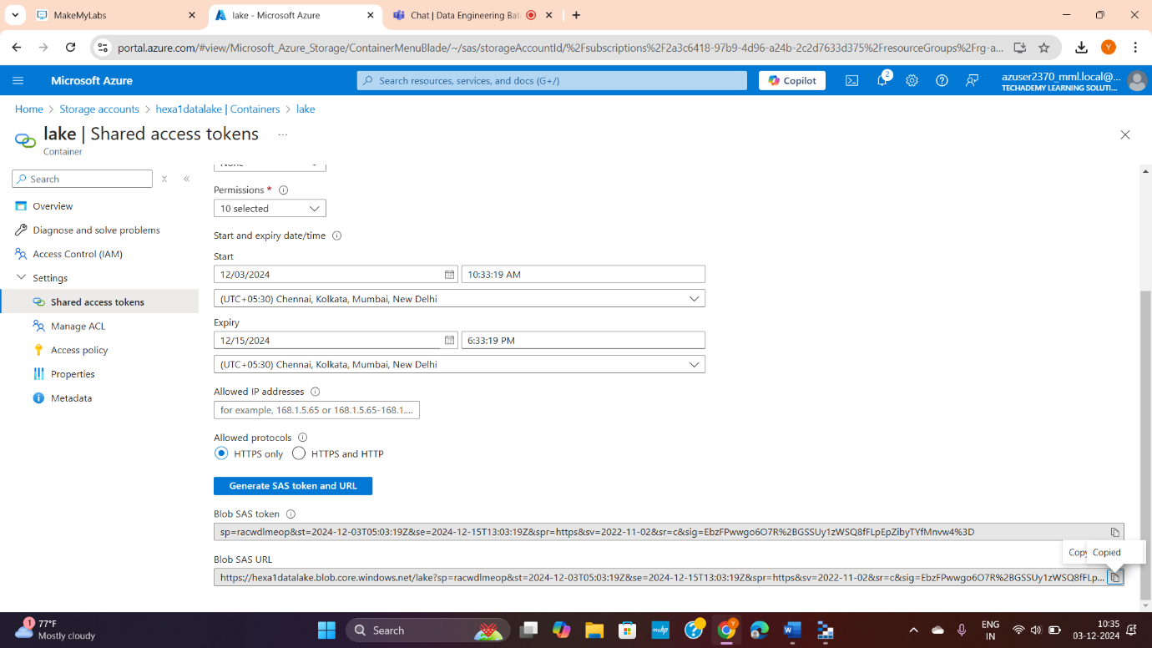

Go to azure eplorer app >> connect dialog >> ADLC Gen2 container >> follow steps below

